The Zonal Business Manager,
Bharti Airtel Limited,
Srinagar.

No: KGP/Estt/2025-26/689 Dated:24-07-2025

Subject: Request for CSR Support – Requirement of Two Commercial Grade RO Water Purifiers for this Institution.

Sir,
Kashmir Government Polytechnic Srinagar, a premier Polytechnic College in Srinagar, Jammu & Kashmir, is dedicated to fostering academic excellence and holistic development for our students. We are writing to Bharti Airtel Limited, a leader in corporate social responsibility, to request your support in enhancing our Institution’s infrastructure under your esteemed CSR program. Our institution serves a diverse student population, many from economically weaker backgrounds. Access to safe and clean drinking water is essential to maintain a healthy learning environment. To address this, we respectfully request the provision of two commercial-grade Reverse Osmosis (RO) purifiers for installation on our institution's premises under your CSR Program.
These purifiers will provide clean drinking water to over 1000 students, significantly improving their health and well-being. The required water purifiers should preferably be RO with a discharge capacity of around 100lph and should be able to cater the needs of the students. We are eager to collaborate with Bharti Airtel Limited to implement this project and are happy to provide additional details. Please contact Er.Tahir Amin Wani on 8716950030 for any additional information.
We sincerely appreciate your consideration of this request and look forward to you.

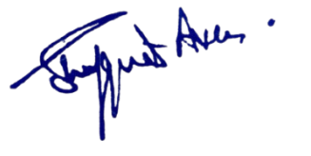
Yours Faithfully

Principal
Kashmir Government Polytechnic College
Srinagar

